Program Information | [Lesson Title]  Tables, Graphs, and Charts, Oh My! |  |  |  |  | TEACHER NAME |  |  |  | PROGRAM NAME
Program Information | [Unit Title] |  |  |  |  | NRS EFL(s)  1 – 3 |  |  |  | TIME FRAME  120 minutes
Instruction | ABE/ASE Standards – Mathematics
Instruction | Numbers (N) |  |  | Algebra (A) |  | Geometry (G) |  |  | Data (D)
Instruction | Numbers and Operation |  |  | Operations and Algebraic Thinking |  | Geometric Shapes and Figures |  |  | Measurement and Data |  | D.1.2, D.2.4,
Instruction | The Number System |  |  | Expressions and Equations |  | Congruence |  |  | Statistics and Probability |  | D.3.14
Instruction | Ratios and Proportional Relationships |  |  | Functions |  | Similarity, Right Triangles. And Trigonometry |  |  | Benchmarks identified in RED are priority benchmarks. To view a complete list of priority benchmarks and related Ohio Aspire lesson plans, please see the Curriculum Alignments located on the Teacher Resource Center (TRC).
Instruction | Number and Quantity |  |  |  |  | Geometric Measurement and Dimensions
Instruction |  |  |  |  |  | Modeling with Geometry
Instruction | Mathematical Practices (MP)
Instruction | □ | Make sense of problems and persevere in solving them. (MP.1) |  |  |  | ☑ | Use appropriate tools strategically. (MP51)
Instruction | □ | Reason abstractly and quantitatively. (MP.2) |  |  |  | □ | Attend to precision. (MP.6)
Instruction | □ | Construct viable arguments and critique the reasoning of others. (MP.3) |  |  |  | □ | Look for and make use of structure. (MP.7)
Instruction | ☑ | Model with mathematics. (MP.4) |  |  |  | □ | Look for and express regularity in repeated reasoning. (MP.8)
Instruction | LEARNER OUTCOME(S)  Students will develop understanding of vocabulary pertaining to tables, graphs, and charts.  Students will make connections between tables, graphs, and charts involving everyday situations and data. |  |  |  |  | ASSESSMENT TOOLS/METHODS  Steps 5 and 6 will serve as evidence of student mastery. During Step 5, the teacher should walk about the room asking students to explain their actions and look for signs of misunderstandings or misconceptions. In step 6, allow students the opportunity to modify their solutions based on what they learn from listening and watching others present their solutions.  Exit Slip: For each of the following, determine which type of display would best display the data.  The change in temperature throughout the year. (Line Graph)  The amount of time outside of school a child spends watching TV, playing video games, exercising, doing school work, and sleeping. (Pie Chart)  The number of home runs hit by the participants of the Home Run Derby. (Bar Graph or Pictograph)  The number of students that scored 0-9, 10-19, 20-29, 30-39, and 40-50 points on a test. (Histogram)
Instruction | LEARNER PRIOR KNOWLEDGE  Students should be familiar with an X-Y plane and how to solve equations.
Instruction | INSTRUCTIONAL ACTIVITIES  Step 1: To help students get prepared for the lesson, make a table with three columns and write each of the following on the board in the first column as ways to organize and display data: tables, line graph, bar graph, pictograph, histogram, and pie chart (see Teacher Answer Sheet). Then distribute Big Minnow Lake Fishing Data handout to students and go through each of the examples explaining the attributes of each display type. Starting with the table, be sure to call attention to the title, column headings, columns, and rows. For the line graph, bar graph, pictograph, and histogram, be sure to call attention to the title, axis labels, and scales of each display. For the pie chart, call attention to the title, the segment labels, and how size of each segment is proportional to the percentage of each category compared to the total.  Step 2: Lead a discussion on the advantages and disadvantages of each visual display, writing down responses in the corresponding columns (see Teacher Answer Sheet). Ask students what they like/dislike about each display and how they compare to each other as they all display the same data.  Step 3: (I do) Teacher leads the Average Household Spending Task using the Think Aloud technique. Pass out the Task 1(Average Household Spending Task) handout to each student and give the students approximately 2 minutes to look over the graphs, chart, and table. Starting with question 1, instructor explains out loud what each display visually represents and the reasoning for selecting the display of choice. For question 2, explain that you just need to add the two percentages displayed by the Pie Chart in order to find the percentage for both. For question 3, rereading the wording of the instructions may be helpful to understand why the 34% is not of total income but of just the categories listed in table 2.1. For question 4, just like the percentages, we need to add the average spending of each from Table 2.1. For question 5, besides discussing each graph separately, be sure to compare how the graphs show the same data differently (see Teacher Answer Sheet).  Step 4: (We do) Teacher and class work through The Growing Trash pile Task together. After giving students time to look over the task, create your graphs using a ruler to make sure your lines are straight and your scale is evenly distributed. Let students decide height of each bar (be sure to keep space between bars). This can also be done using Excel or other statistical software if available. Before moving to the remaining questions, make sure each student has correctly created each graph (depending on your class dynamics, you may want to have students check another student’s work). Students should be able to provide the answer to question two without help, but be sure to show how the difference can be calculated and visualized in each of the different displays (including the table). For questions 3 through 6, allow students time to come up with an answer, have students pair up and discuss possible answers. If no one is willing or able to answer, provide students with hints without giving away the answer. For question 3, you can suggest that students look forward to question 6 for a hint. For question 4, suggest students try to approximate how many of the 1960 trashcans can fit in the 2000 trashcan. For question 5, ask students who would benefit from making it look like the average trash discarded grew more than it actually did. For question 6, if students don’t know where to start, ask them to refer back to Polya’s four steps and suggest that they try to write an algebraic equation that represents the question.  Step 5: (You do) Students independently work through The Name Game Task. Students should work individually on this task, but may need some explanation of the instructions. After passing out the handouts, walk around the room silently monitoring the students’ progress. When you see them run into difficulties, try not to answer their questions directly; instead, remind them of definitions from the introduction or similar situations from the first two tasks.  Step 6: Have each student (or pair) share their visual displays for Task 3 with the entire group. Lead a discussion on the difference between qualitative and quantitative data (and their relation to the different types of displays), hopefully based on the students’ findings from Task 3. |  |  |  |  | RESOURCES  Slide N’ Measure Compass (can double as a straightedge or ruler)  Big Minnow Lake Fishing Data  Average Household Spending Task  The Growing Trash Pile Task  The Name Game Task  Microsoft Excel  http://illuminations.nctm.org/lessondetail.aspx?id=l812
 | DIFFERENTIATION
Reflection | TEACHER REFLECTION/LESSON EVALUATION
Reflection | Additional Information  NEXT STEPS  Have students collect and organize a variety of data types using tables and displays. You can also introduce students to displays of more than one variable.  PURPOSEFUL/TRANSPARENT  This lesson starts with the introduction to different types of displays and the differences between them. Then the teacher goes through a task providing students with the opportunity to gain understanding and build their vocabulary before giving the students the chance to explore the concepts on their own.  CONTEXTUAL  This lesson uses data from real life situations and requires students to read and make judgments about different types of displays that are commonly found throughout the media and can be utilized in nearly every facet of life.  BUILDING EXPERTISE  Students will build their understanding of different types of displays allowing them to make sense of displays found throughout their everyday lives and be critical of those that are used to persuade them to feel a certain way
NOTE: The content in the Additional Information box exceeds what is required for the OBR Approved Lesson Plan Template. This information was provided during the initial development of the lesson, prior to the creation of the OBR Approved Lesson Plan Template. Feel free to remove from or add to the Additional Information box to suit your lesson planning needs.
Vocabulary Sheet

Bar Graph — a display type where the number of data values falling in a category is represented by the height or length of a rectangle (a “bar”).
Histogram — a display type similar to a bar graph, but without spaces between categories to show connection between categories.
Interpolate — estimate the y-values for all x’s in between the minimum and maximum x-values.
Line Graph — a display type which connects points with line segments to better show a trend with categories listed on the x-axis and values listed on the y-axis.
Pictograph — a display type similar to a bar graph, but the height or length of the bars is replaced with symbols or pictures to represent the number of data values falling into each category.
Pie Chart — a display type that displays the relative number of data values in each category by the size of the corresponding sector or slice of a circle where the whole circle represents 100% or all of the data values.
Qualitative — data that is expressed using a means other than numbers. Quantitative data can include pictures, words, and sound.
Quantitative — data that is expressed using numbers and frequencies. Lists of people’s ages, heights, or weights are all examples of quantitative data.
Examples

Big Minnow Lake Fishing Trip
Day | Number of fish caught
Monday | 20
Tuesday | 25
Wednesday | 15
Thursday | 13
Friday | 12
Saturday | 15
Total | 100

Line Graph:  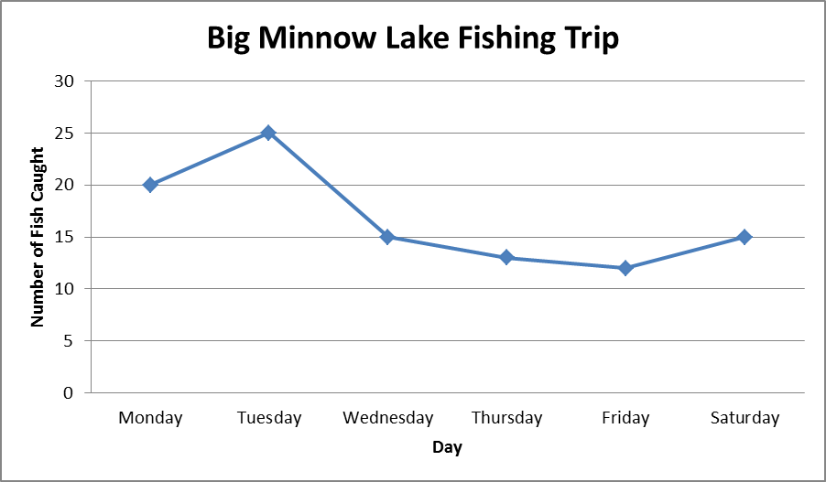 | Bar Graph 1 (in order of number of fish caught)  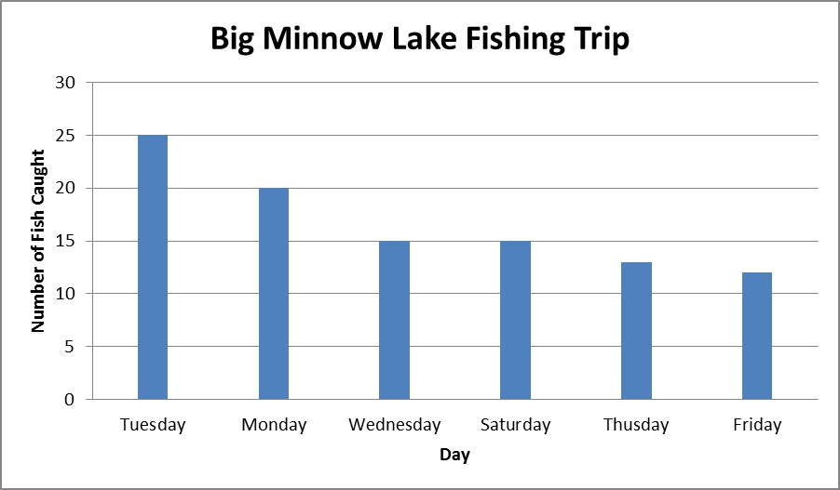
Bar Graph 2 (in order of date):  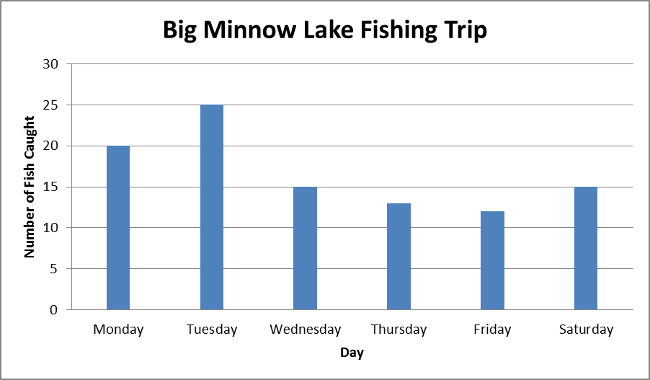 | Pictograph:  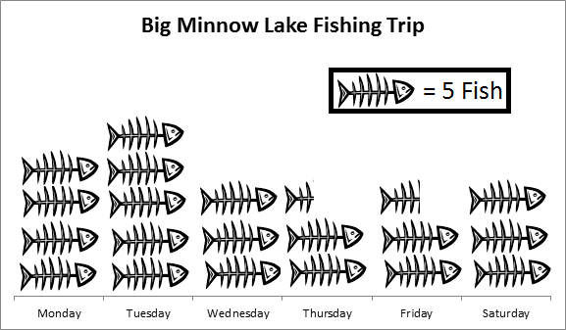
Histogram:  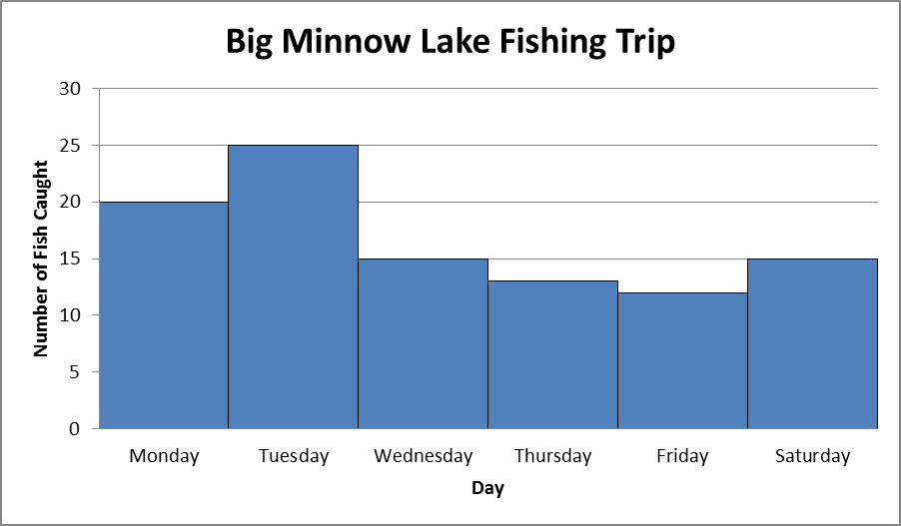 | Pie Chart:  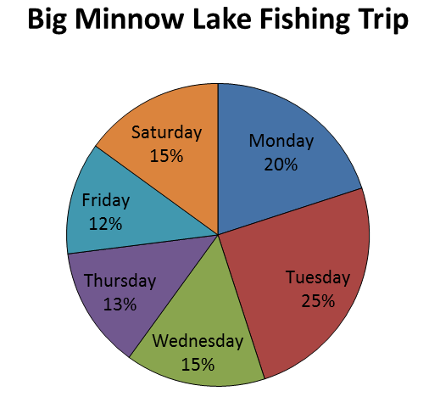

Average Household Spending Task
Average Household Spending  Table 2.1 Average Spending per household unit | 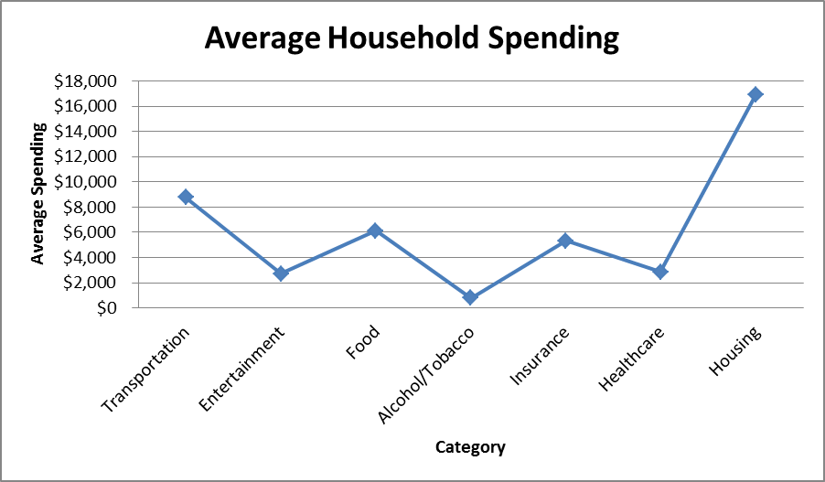  Figure 2.1 Line Graph
  Category | Avg Spending
  Transportation | $8,758
  Entertainment | $2,698
  Food | $6,133
  Alcohol/Tobacco | $780
  Insurance | $5,336
  Healthcare | $2,853
  Housing | $16,920
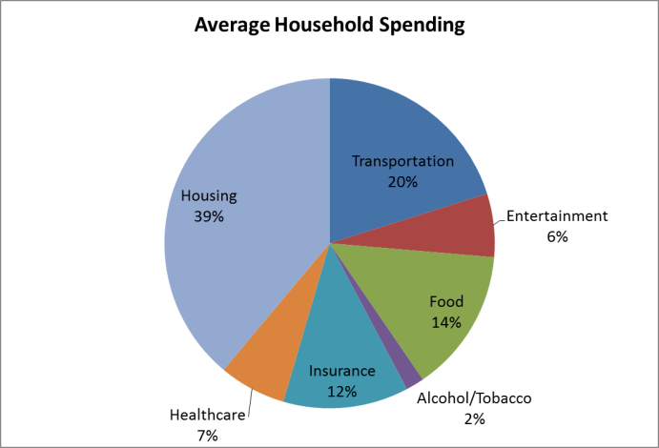  Figure 2.2 Pie Chart | 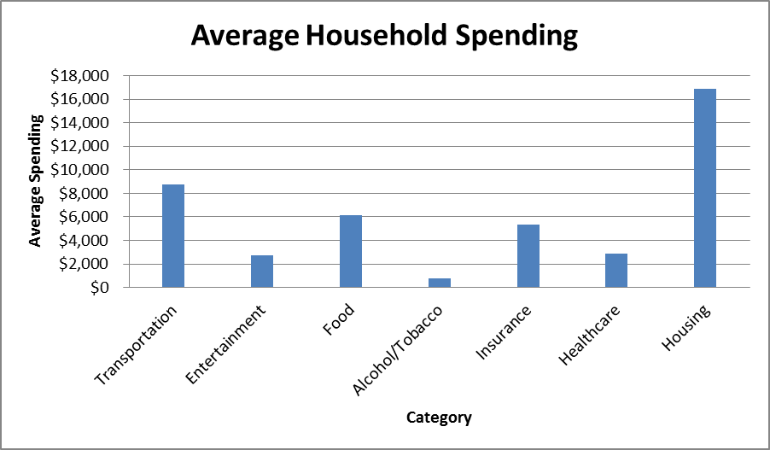  Figure 2.3 Bar Graph
For the following questions, refer to the data in Table 2.1 and Figures 2.1–2.3. Table 2.1 gives the breakdown of select categories of spending for the average family unit in 2008 (an average family unit is defined as 2.5 people, so a household of 5 people would be considered as 2 units). Note that the original data set has several more categories of spending not included in this data.

1. How much money did the average unit spend on food and transportation?

2. According to the chart, what percent of money was spent on food and transportation?

3. Return to Question #2. Is the answer you gave the percentage of total income that is spent on food and transportation? If not, what is this percent out of?

4. What are the advantages and disadvantages of each of the three figures in conveying the information?

5. Which of the three figures do you think best conveys the information shown in Table 2.1?
The Growing Trash Pile Task
Year  Average Units of Trash Discarded by Household  Table 2.2 Average units of trash discarded per household |  | 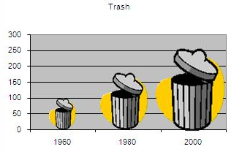  Trash Discarded  Year  Figure 2.4 Pictograph
  Trash Discarded
  1960 | 100
  1980 | 175
  2000 | 250
Bar Graph |  |  | Line Graph
For the following questions, refer to the data in Table 2.2.

1. Use the space above to construct a bar graph and a line graph for the data.

2. What was the increase in average trash discarded between 1980 and 2000?

3. What meaning do the lines in the line graph have?

4. How might Figure 2.4 cause the data to be misinterpreted? Is this same problem present in your bar graph or line graph? How might you prevent this problem?

5. Based on your answer to #4, who might stand to benefit from distorting the data like Figure 2.4 does?

6. Use the line graph to interpolate the units of trash discarded per household in 1985. What assumption does this estimate make?

The Name Game Task

Bar Graph |  | Histogram
For this task, you will need to collect and organize your own data.
1. Choose five letters of the alphabet. Now take 30 seconds per letter and write down as many people you know as possible whose first name begins with that letter (two and a half minutes total). Tally the number of names per letter and then create a bar graph to represent your data (there should be five bars).
2. Return to all the names you wrote down in question one and place them each in a five-year age bracket. For example 15-19, 20-24, 25-29, etc. You may have to estimate some ages if you are not sure about them. Create a histogram for these data.
3. Try to create a histogram for #1. What problems do you run into?

4. What differences do you notice between a bar graph and a histogram?

5. What types of information would be best represented by a bar graph? By a histogram?
Teacher Answer Sheet

From Lesson Plan:

Display Type | Advantages | Disadvantages
Table | Organizes data neatly (great for all types of data). | Hard to compare between categories visually.
Line graph | Shows connection between categories as category values increase. Needs to be quantitative data (numbers). | Data must be ordered and connected.
Bar graph | Visually displays differences between categories. Can display quantitative data as well as frequency of qualitative data (words). | Has gaps between categories when sometimes it isn’t appropriate.
Pictograph | Same as bar graph, but makes connection between what the data represents. | More to translate in order to understand the display and partial images hard to translate.
Histogram | Shows connection between bars as categorical value increases. | Categorical value determines placement of data in display and cannot be reordered.
Pie Chart | Makes for easy comparison between categories and categorical amounts in relation to total. Great for qualitative data. | Loss of visual totals and order of categorical values.

Task 1:
- $14,891

- 34%

- No, it is 34% of the spending listed in table 2.1 as opposed to all possible spending. There could be categories left off of the table.

Figure | Advantages | Disadvantages
Line Graph | Shows difference between categories nicely. | Shows inappropriate connection between categories.
Pie Chart | Shows good comparison between all categories | No idea about the actual value of each of the categories.
Bar Graph | Shows total of each category and keeps each category separate. | Hard to see compare some categories, such as entertainment and healthcare. It is also difficult to tell exactly how much was spent in each category.

- Pie Chart as it allows for easy comparison between all categories listed and displays percentage of spending compared to other expenses included. However, we do need to keep in mind that the percentages listed are not the percentage of total spending. Rather, it is just the percentage of spending reported by the table.

Task 2:
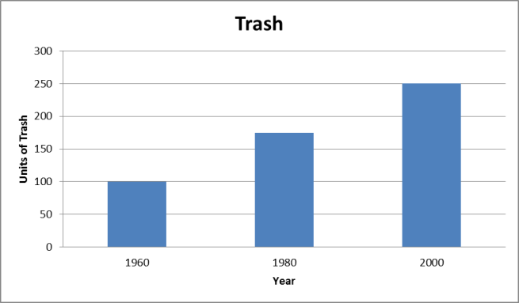
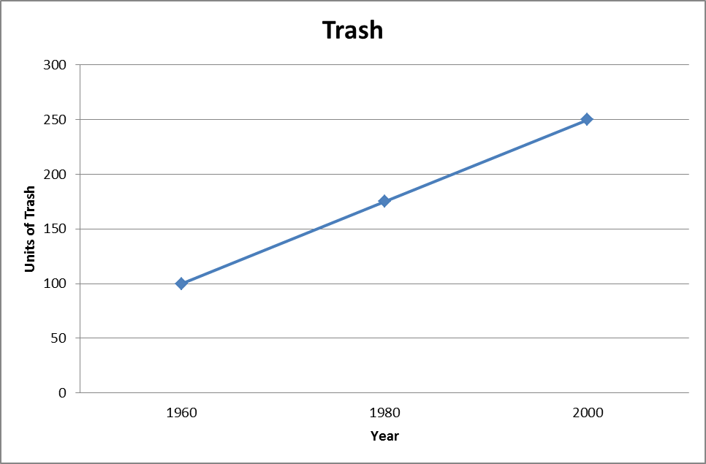

- 75 units of trash
- An approximation of the number of units of trash between data points.
- The amount of trash increased by 150%, but because the size of the trash can was increased in width as well as height, it looks like it increased much more than that. This problem doesn’t exist in the bar graph.
- Anyone who wants to make it seem that the amount of trash has grown more per household than it really has (environmentalists).
- units of trash. It assumes that the growth in units is linear.
Task 3:
Answers for 1 and 2 will vary between students. Make sure age groups in 2 are distributed evenly.
- No connection between the different letters.
- Histograms: order matters and no separation between categories.
Bar Graphs: order doesn’t matter and categories are separated.
- Bar graphs are best for categories that are distinct from each other and order doesn’t matter such as frequency of responses to favorite color or gender. Histograms are best for data that are ordered and connected such as age groups or test scores.

Consumer Expenditures (U.S. Department of Labor, U.S. Bureau of Labor Statistics, April 2009).

